

**Silvan Primary School**

School No. 1801

Main Rd, Silvan, Victoria 3795

Telephone: (03) 9737 9258

Email: [silvan.ps@education.vic.gov.au](mailto:silvan.ps@education.vic.gov.au)

Website: [www.silvanps.vic.edu.au](http://www.silvanps.vic.edu.au)

**NEWSLETTER NO. 13 August 23rd , 2024**

|  |  |
| --- | --- |
| **DATES TO REMEMBER** | |
| **2024** | |
| **Fri 23rd August** | **Curriculum Day (Pupil Free)** |
| **Thurs 29th August** | **Father’s Day Stall** |
| **Wed 4th Sept** | **Talent Quest Heats – Lunch Time** |
| **Mon 9th – Fri 13th Sept** | **Book Fair at the School** |
| **Wed 11th Sept** | **Restaurant Day** |
| **Wed 18th Sept** | **Talent Quest Final – 11.30 am** |
| **Thurs 19th Sept** | **P-3 Sleepover after school** |
| **Fri 20th Sept** | **P-3 Sleepover Activity Day**  **Last day of term 2.30 pm dismissal** |

**AWARDS**

**TALENT QUEST**

It is that time of the year again, Talent Quest. All students are encouraged to fly it alone or team up to enter this year’s Talent Quest competition. Acts can take

the form of song, dance, skit, comedy act, magician show, instrumental or other. P-6 Heats will be conducted prior to the finals.

**Talent Quest Heats:**

*Wednesday 4th September* 12.45 pm – 2.15 pm

**Talent Quest Final:**

*Wednesday 18th September* 11.30 am – 12.30 pm.

**CURRICULUM DAY – FRI 23RD AUGUST**

Please note that Friday 23rd August is a Curriculum Day here at Silvan Primary. It will be a pupil free day as staff will be attending a Numeracy Workshop by Dr Ryan Dunn at Scoresby. Please remember to make arrangements for your child as there will be no school this day.

**RESTAURANT DAY 2024**

This year's Restaurant Day will be held on Wednesday 11th September from 1:15 p.m. - 2:30 p.m. Invitations will be sent out mid-August. RSVP and dietary requirements are essential for catering purposes. Hopefully we will see you there.

**BOOK FAIR**

Beginning Monday 9th September and continuing through to Friday 13th September, come and browse through our

Book Fair. Checkout assortment of products including posters, $ 5.00 book boxes, stationery, general stock and Whacky packs.



**FREE KNITTED AND CROCHETED BLANKETS**

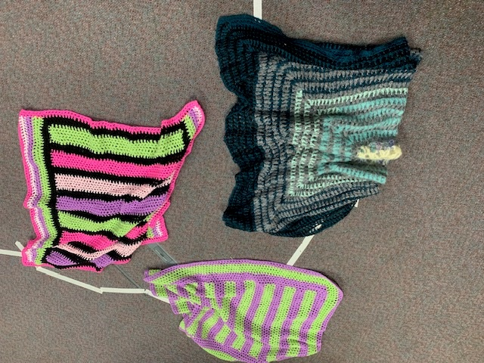Come one, come all. Our friends at Cottage by the Sea have donated a variety of knitted and crocheted blankets and throw rugs to the school. Please visit the upcoming Book Fair to receive a free blanket with every purchase.